**General:**

It’s the 2nd Quarter of 2021 and housing prices are soaring with no end in sight for the immediate future, critical building elements such as lumber are at an all-time high. In 2020, the corona virus lockdown which affected the economy and resulted in lowered interest rates by the federal government, individuals and families who had previously chosen to live in city centers to be close to their jobs have either lost their jobs or have discovered that they can function on their jobs remotely. This realization also permeates the employers who in certain cases have begun to look into avenues to allow employees to work from home more. All of these different factors have attributed to a high demand for homes, people who would have chosen to rent are deciding to move out of crowded city centers and buy homes in suburbs or even the country.

Qlik Sense’s intuitive cockpit and report creation method allows users to visualize analytical areas of interest, its accessibility in mobile devices allows for access to a broader user-base. Also, there is the ability to create extensions that can be used for better visualized dashboards. Hence, this will be the preferred tool for exploring the data on housing prices and interactively visualize aspects of the data.

**Summary: Project Objectives**

Considering low interest rates and remote work, there is a high demand for home purchase, but how can a person decide if this is a good time to purchase a home since homes are relatively time high cost at this time, is this trend going to continue? Can we expect that after a home is purchased that its value continues to remain relative to its purchase price with proper maintenance? What are the odds of prices dropping if a person decides to wait for another year to purchase a home? In this project, I will attempt to give a prospective some insight into what is going on and what to expect in the coming year. Overall, attempting to answer the question of when is a good time to purchase or sell a home given the current situation.

**Datasets:**

**KPI 1**: Rate of Increase in the prices of homes in 2020 and 2021 from other years: this KPI will explain how much the prices of homes have increase from previous years to give the user an idea to how much more demand there is than the expected growth increase.

**KPI 2:** Ratio of the Average number of homes bought YTD vs Previous YTDs: We know that there is an increase in home prices but this KPI will give an insight to how much that differs from the same time in the previous year, hence, a better understanding to the demand.

**KPI 3:** YoY Average number of homes sold with price drops: When a home is in the market for an extensive period, the realtor/owner may decide to drop the price of the home to sell it off sooner. How many instances of price drops we have had in the past year vs the same period in the previous year is an indicator to how fast homes are selling.

**KPI 4:** MoM number of days on the market: This KPI is an indication of how many days a seller will expect to have to wait to complete the sale of a home in 2021. Also, a prospective buyer can use this KPI to determine how long a desired home may be on the market.

Screenshots:

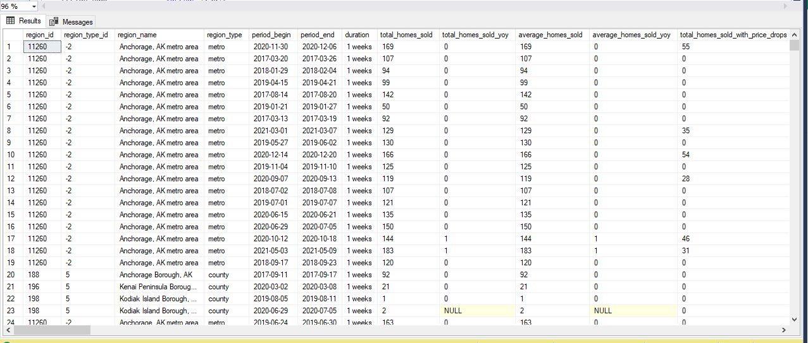

Links: <https://www.redfin.com/news/data-center/>